**Which command will give a version of jQuery?**

The command $.ui.version returns jQuery UI version.

**In what scenarios jQuery can be used?**

jQuery can be used in following scenarios:

* Apply CSS static or dynamic
* Calling functions on events
* Manipulation purpose
* Mainly for Animation effects

**What is jQuery connect?**

A ‘ jQuery connect’  is a plugin used to connect or bind a function with another  function. Connect is used to execute function from any other function or plugin is executed.

Using connect function we can connect to an event of a dom element also, so that we can use same connect function for both dom elements and for the functions.  
Example:  
  
function Class1(){  
this.fun1 = function(){  
called1 = 'calss1-fun1';  
}  
}  
var c1 = new Class1();  
function Class2(){  
this.fun1 = function(){  
called2 = 'class2-fun1';  
}  
}  
var c2 = new Class2();  
$.connect(c1,'fun1',c2,c2.fun1);  
Here we connected "fun1" from c2 object to "fun1" from c1 object. When ever c1.fun1 function is executed c2.fun1 will also execute.

**Whether we need to add jQuery file in both Master and Content page?**

jQuery file should be added to the Master page and can use access from the content page directly without having any reference to it.

**Can we call C# code behind using jQuery?**

Yes, we can call C# code from jQuery as it supports .net application.

**What is the use jQuery.data method?**

jQuery.data methods is used to associate the data with the DOM nodes and the objects. This data method makes the jQuery code clear and concise.

**What is the difference between size and length of jQuery?**

Size and length both returns the number of element in an object. But length is faster than the size because length is a property and size is a method.

**Can we add more than one ‘document.ready’ function in a page?**

Yes, we can add more than one document.ready function in a page. But, body.onload can be added once in a page.

**What is the use of jQuery load method?**

jQuery load method is a powerful AJAX method which is used to load the data from a server and assign the data into the element without loading the page.

**Whether our own specific characters are used in place of $ in jQuery?**

Yes, We can use our own variable in place of $ by using the method called no Conflict () method.

var sample = $.noConflict()

**What are the four parameters used for jQuery Ajax method?**

The four parameters are

* URL – Need to specify the URL to send the request
* type – Specifies type of request(Get or Post)
* data – Specifies data to be sent to server
* Cache – Whether the browser should cache the requested page

**Is it that success() returns earlier than complete()?**

**Yes**; the AJAX success() method runs before the complete() method.

Below is a diagram illustrating the process flow:

[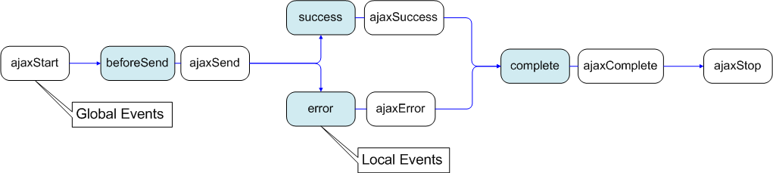](https://i.stack.imgur.com/JogVo.png)

It is important to note that

* The success() (Local Event) is only called if the request was successful (no errors from the server, no errors with the data).
* On the other hand, the complete() (Local Event) is called regardless of if the request was successful, or not. You will always receive a complete callback, even for synchronous requests.

**What is the use of jQuery filter?**

The jQuery filter is used to filter the certain values from the object list based on the criteria. Example is to filter certain products from the master list of products in a cart website.

**Which program is useful for testing jQuery?**

QUnit is used to test jQuery and it is very easy and efficient.

**What is CDN?**

CDN is abbreviated as Content Distribution network and it is said to be a group of companies in different location with network containing copies of data files to maximize bandwidth in accessing the data.

**How can we debug jQuery?**

There are two ways to debug jQuery:

Debugger keyword

* Add the debugger to the line from where we have to start debugging and then run Visual Studio in Debug mode with F5 function key.
* Insert a break point after attaching the process

**What are all the ways to include jQuery in a page?**

Following are the ways to include jQuery in a page:

* Local copy inside script tag
* Remote copy of jQuery.com
* Remote copy of Ajax API
* Local copy of script manager control
* Embedded script using client script object

**What is the use of jQuery.ajax method ()?**

jQuery.ajax method is used for asynchronous HTTP requests.

**Where can we download JQuery?**

jQuery javascript can be downloaded from jQuery official website – www.jquery.com

**Is jQuery is a replacement of JavaScript?**

No, jQuery is not a replacement of JavaScript.

**What is called chaining?**

Chaining is used to connect multiple events and functions in a selector.

**What are the advantages of jQuery?**

Following are the advantages of jQuery:

* Just a JavaScript enhancement
* Coding is simple, clear, reusable
* Removal of writing more complex conditions and loops

**What is the use of jQuery each function?**

jQuery each function is used to loop through each and every element of the target jQuery object. It is also useful for multi element DOM, looping arrays and object properties.

**How method can be called inside code behind using jQuery?**

$.ajax can be called and by declaring WebMethod inside code behind using jQuery.

**Which is the fastest selector in jQuery?**

ID and Element are the fastest selectors in jQuery.

**What is the slowest selector in jQuery?**

Class selectors are the slowest selectors in jQuery.

**Where jQuery code is getting executed?**

jQuery code is getting executed on a client browser.

**What is the method used to define the specific character in place of $ sign?**

‘NoConflict’ method is used to reference a jQuery and save it in a variable. That variable can be used instead of Sign.

**Why jQuery is better than JavaScript?**

jQuery is a library used for developing Ajax application and it helps to write the code clean and concise. It also handles events, animation and Ajax support applications.

**What are the types of selectors in jQuery?**

There are three types of selectors in jQuery:

* CSS Selector
* XPath Selector
* Custom Selector